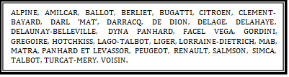

**French Car Club Canberra membership form**

Name:

Address:

Email:

Phone:

French Car(s) currently owned:

Registration numbers:

If historic, then nominated club:

Please pay $20 annual membership by June, include your name in the payment field.

$25 for new members.

Bendigo Bank

BSB 633 000

Account no. 178618690

Account name: French Car Club of Canberra Inc

Complete and return this form via email to bardot@iinet.net.au after payment